Assignment 1
To capture live network packets using Wireshark and identify basic network protocols such as TCP, UDP, IP, DNS, and ICMP.

Step 1: Launch Wireshark
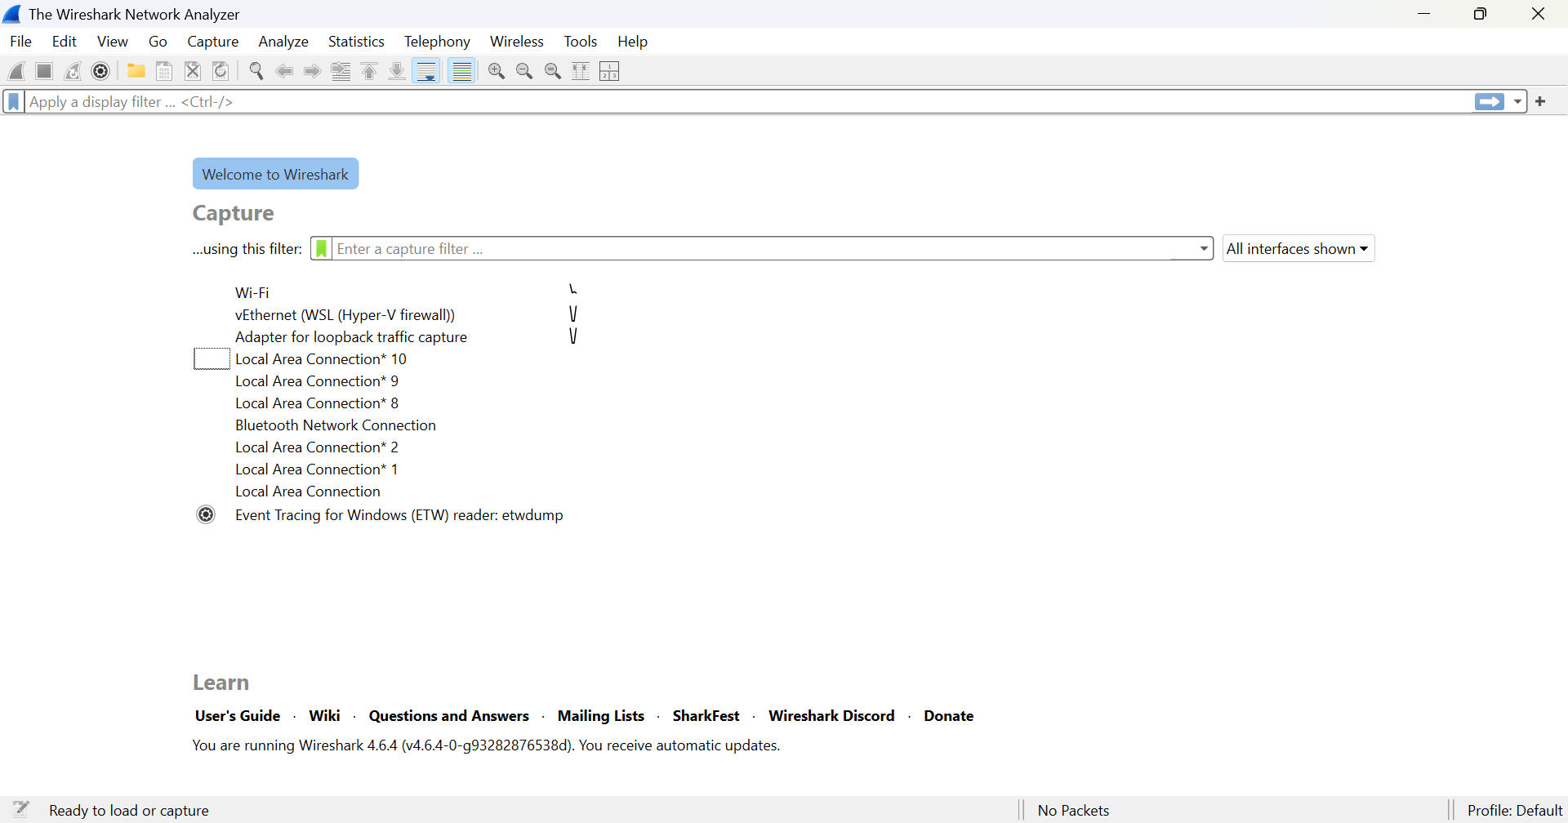

Step 2: Start Packet Capture
The active network interface (Wi-Fi) was selected, and packet capturing started.
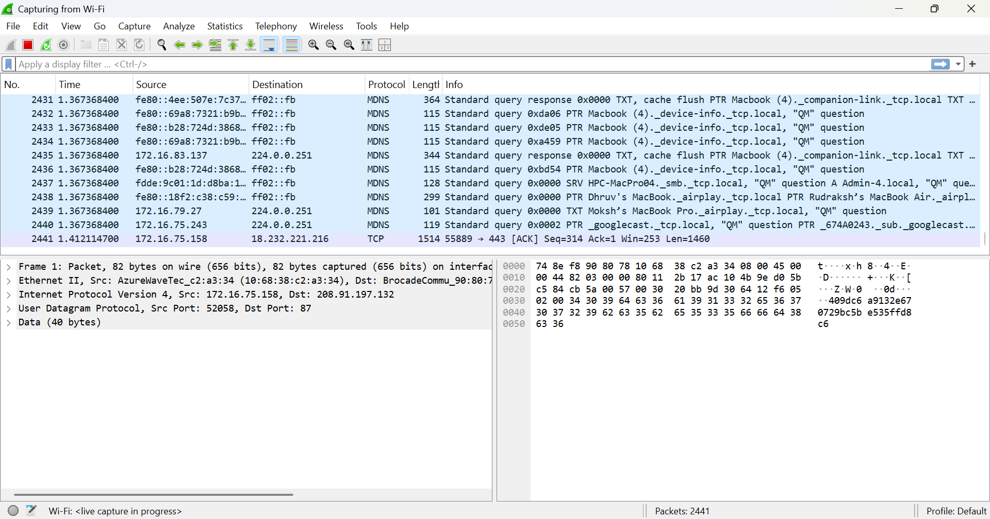

Step 3: Generate Network Traffic
To generate traffic: Opened a web browser and visited google.com

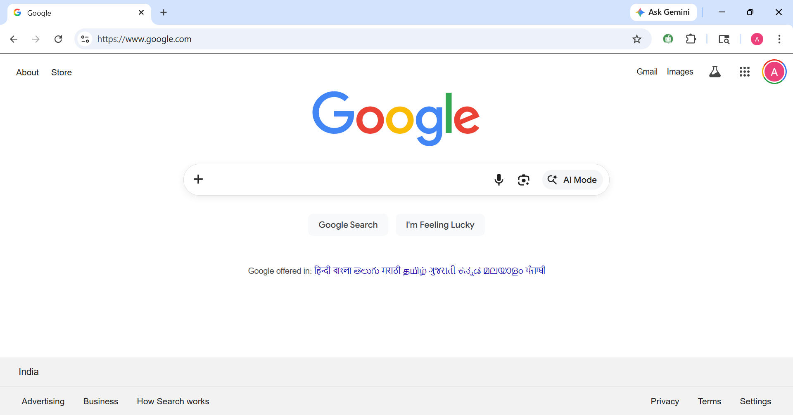
Step 4: Stop Capture
The packet capture was stopped using the red stop button in Wireshark.
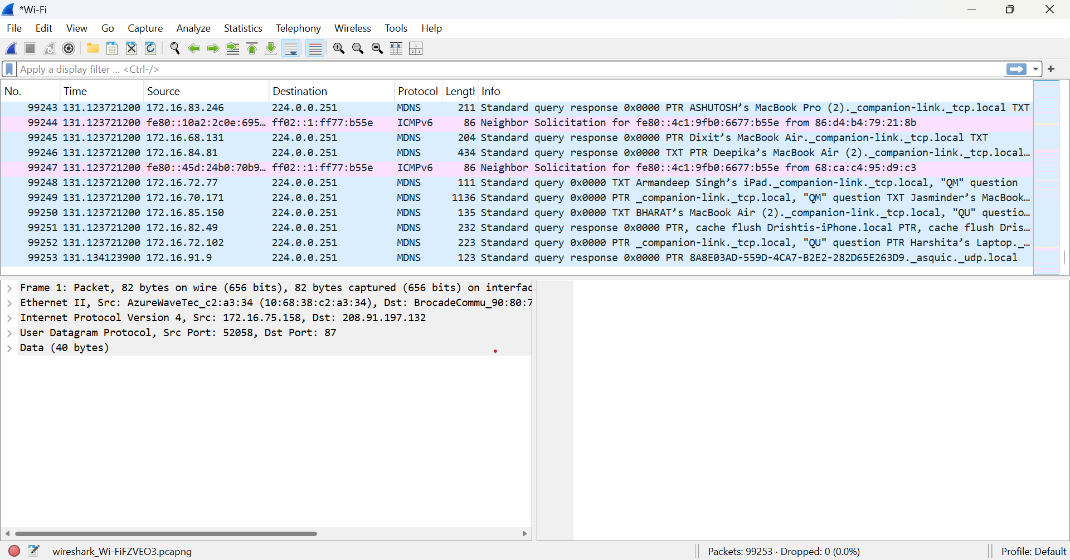

Step 5: Apply Filter
Ip Filter Analysis

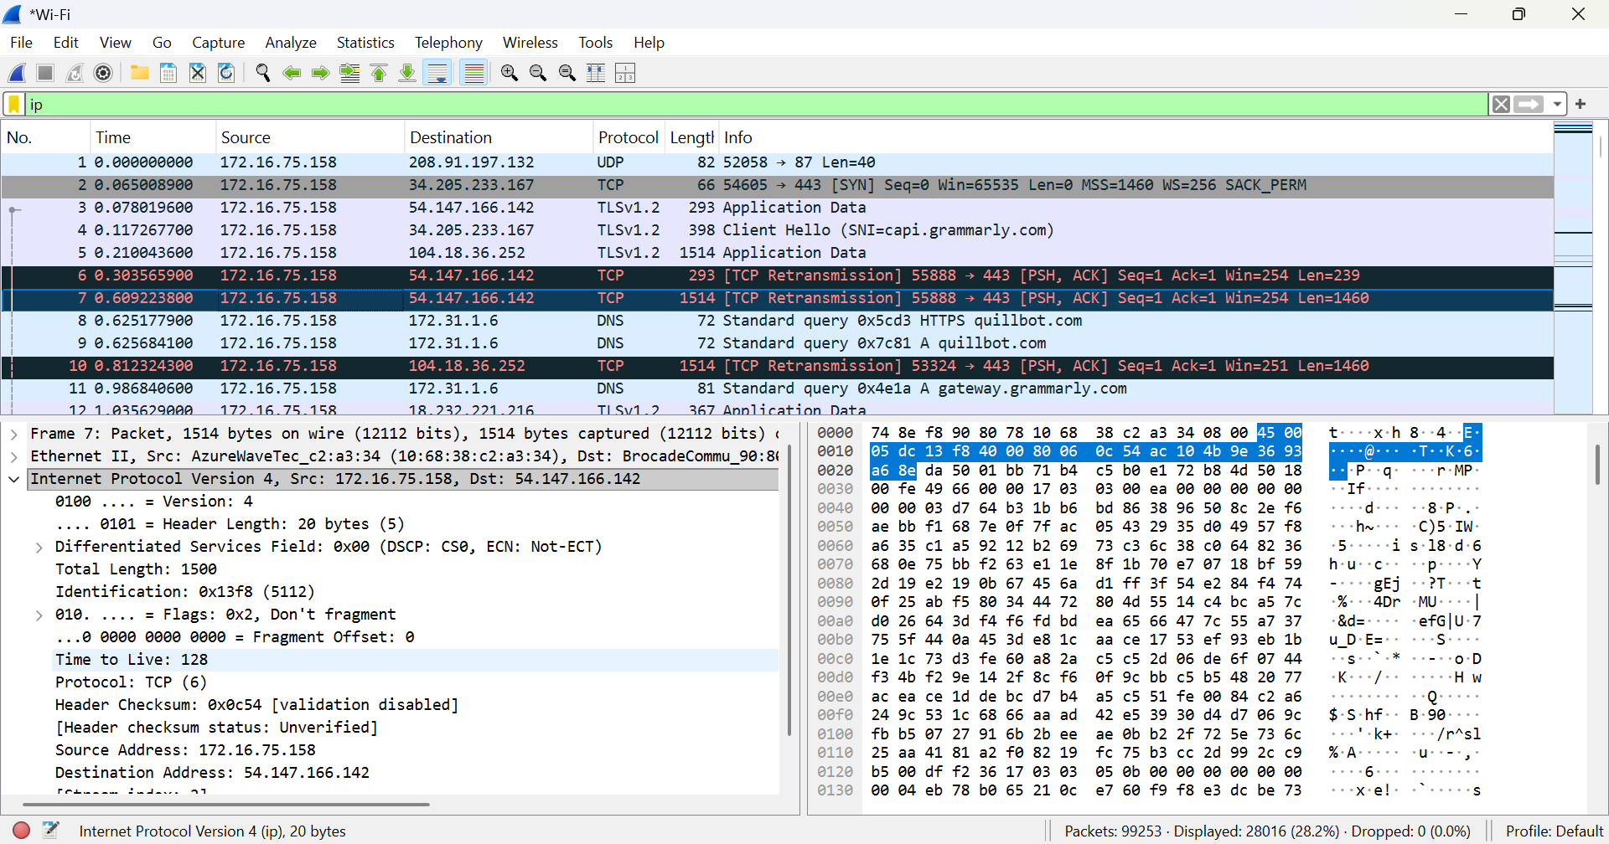
A packet was selected and analyzed using Wireshark. The following details were observed:
- Ethernet Header:
Shows source MAC address (AzureWaveTec device) and destination MAC address (network device).
- IP Header:
  - Version: IPv4
  - Source IP Address: 172.16.75.158
  - Destination IP Address: 54.147.166.142
  - Time to Live (TTL): 128
  - Protocol: TCP
- TCP Header:
  - Source Port: 55888
  - Destination Port: 443 (HTTPS)
  - Flags: PSH, ACK
  - Indicates data transmission over a secure connection
- Payload Data:
Contains encrypted application data (since HTTPS is used)

TCP Filter Analysis

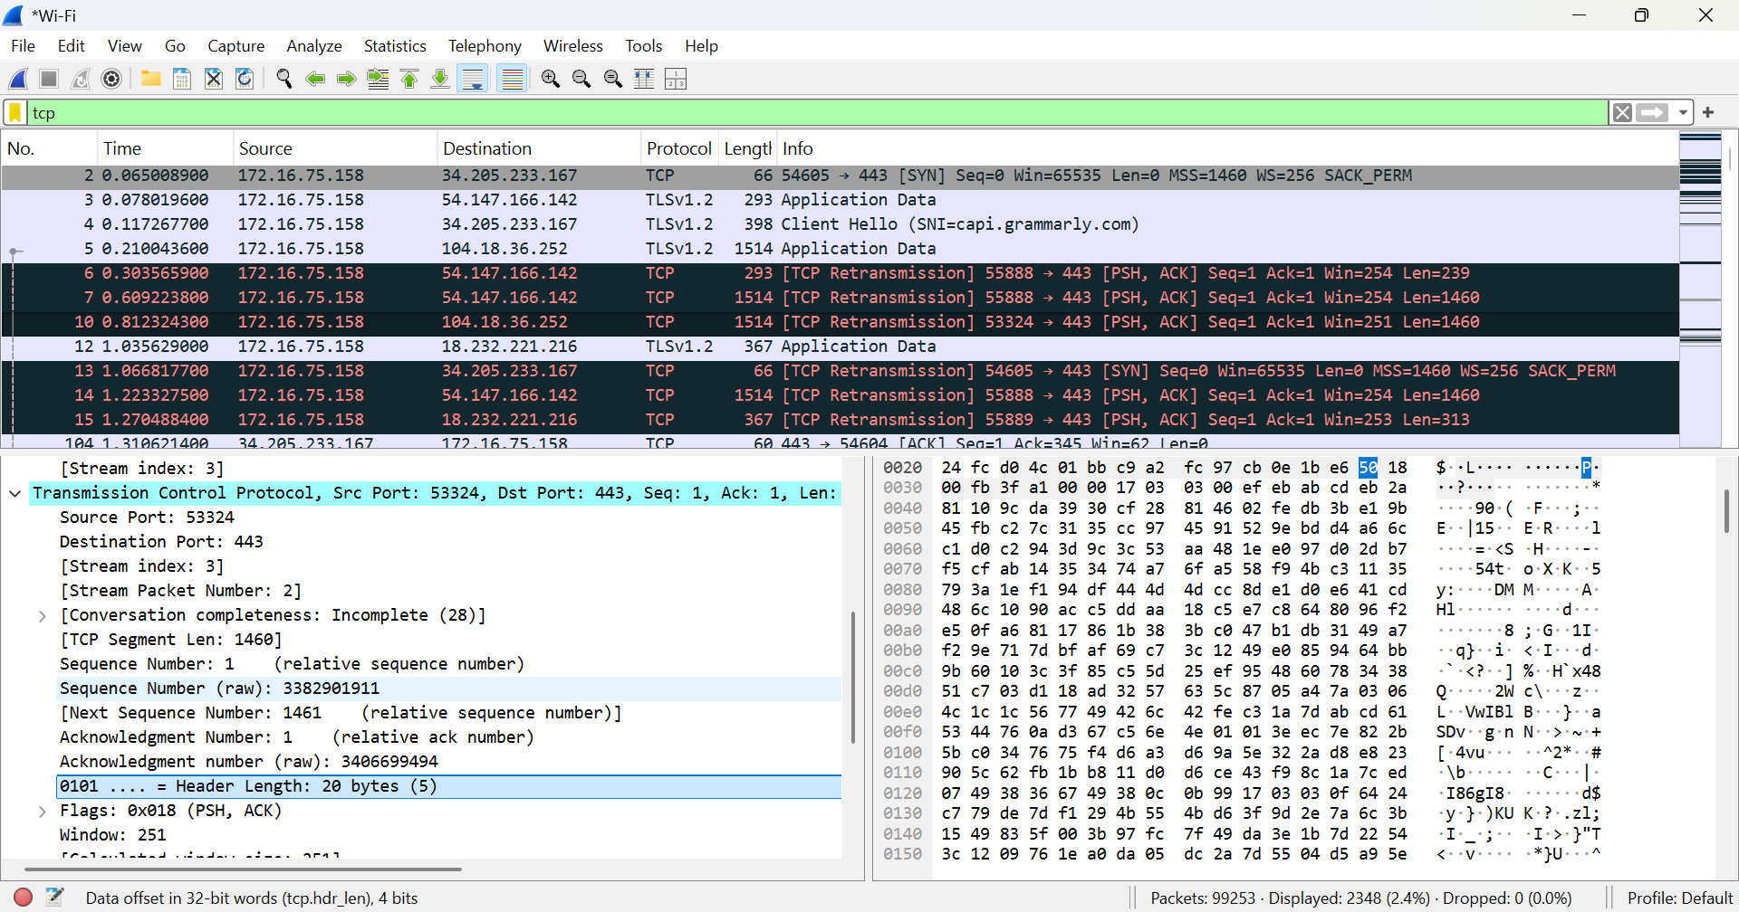

TCP packets show connection-oriented communication. The presence of:
- SYN flag indicates connection establishment
- ACK flag confirms receipt of data
- PSH flag indicates immediate data transfer

Detailed TCP segment analysis shows:
- Sequence Number: 1
- Acknowledgment Number: 1
- Header Length: 20 bytes
- Window Size: 251
- Flags: PSH, ACK

DNS Filter Analysis
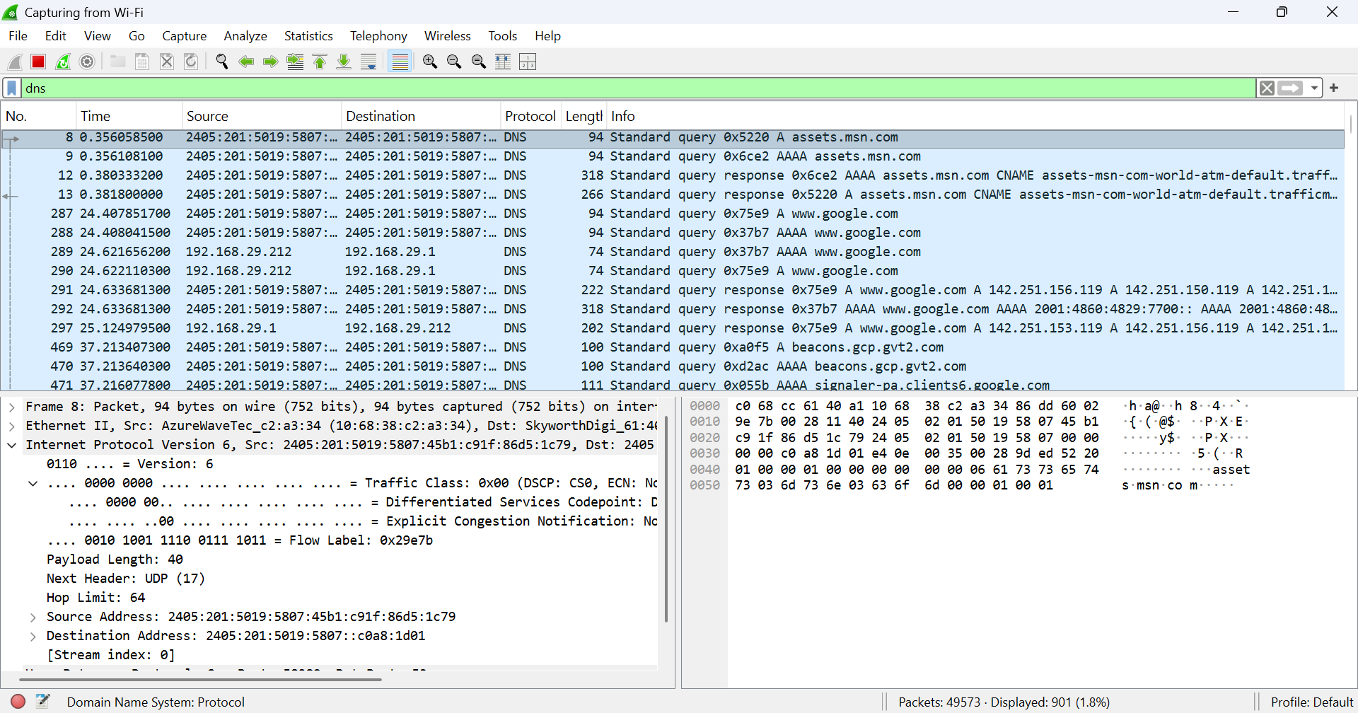
The dns filter was applied to display Domain Name System packets. DNS is responsible for translating domain names into IP addresses. The captured packets show DNS queries and responses between the client and DNS servers.

- Protocol: DNS
- IP Version: IPv6
- Source Address: 2405:201:5019:5807:... (your system)
- Destination Address: DNS server (same IPv6 range)
- Query Type: A (IPv4 address), AAAA (IPv6 address)
- Domains Queried:
  - assets.msn.com
  - www.google.com
  - beacon.gcp.gvt2.com

ICMP Filter Analysis:

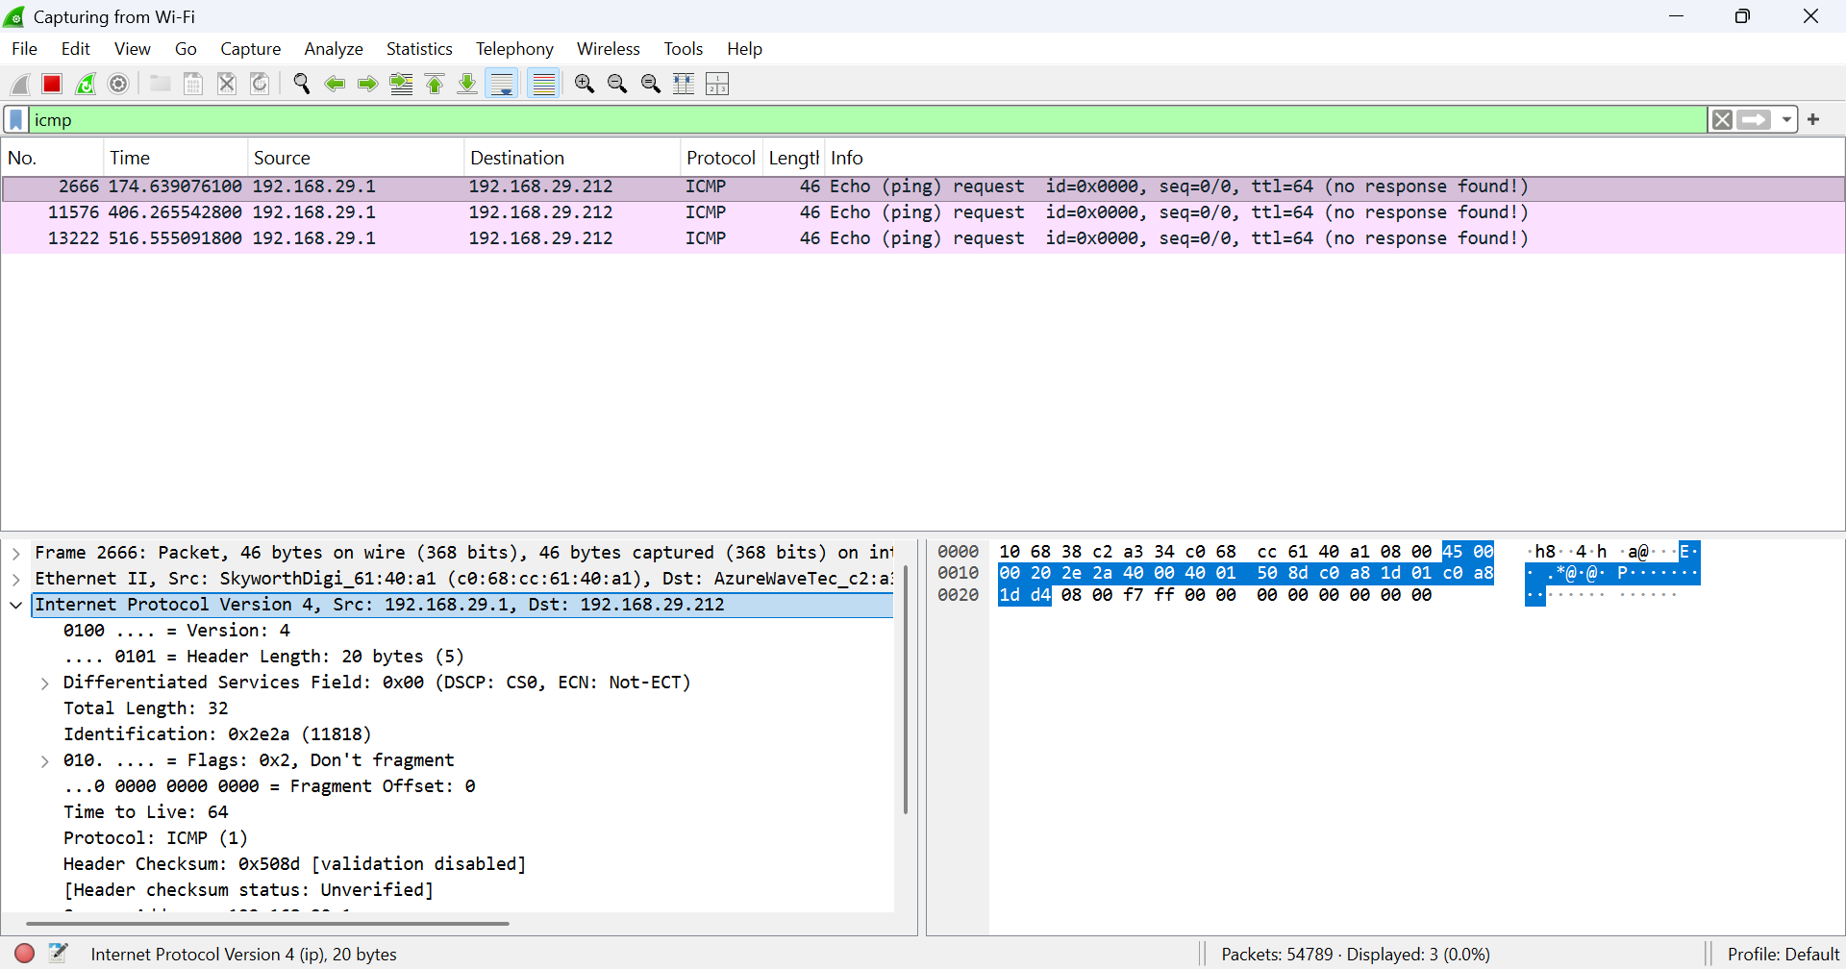

The icmp filter was applied to display Internet Control Message Protocol packets. ICMP is used for diagnostic and error-reporting purposes, such as the ping command.

- Protocol: ICMP
- Source IP Address: 192.168.29.1
- Destination IP Address: 192.168.29.212
- Message Type: Echo (ping) request
- TTL (Time to Live): 64

